### AGGREGATE FUNCTIONs AND JOINs

**Left JOIN**

**Introduction**

In this JOIN statement, all the records of the left table and the common records of the right table are returned in the query. If no matching rows are found in the right table during the JOIN operation, these values are assigned as NULL.

Here is the syntax of the LEFT JOIN clause:

SELECT columns

FROM table_A

LEFT JOIN table_B ON join_conditions

In this syntax,

* *columns*: Column names from *table_A* or *table_B.*
* *table_A, table_B*: The names of the joined tables.
* *join_conditions:* It specifies the conditions to evaluate for each pair of joined rows.

LEFT JOIN and LEFT OUTER JOIN keywords are exactly the same. OUTER keyword is *optional*.

SELECT columns

FROM table_A

LEFT OUTER JOIN table_B ON join_conditions

**💡Tips:**

* If no match is found for a particular row, NULL is returned.

### Example

Suppose you want to join the "employees" table and the "departments" table. In this example, a LEFT JOIN has been created that is based on the *emp_id*columns in the two tables:

**Tables**

"employees" table:

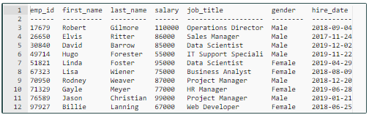

"departments" table:

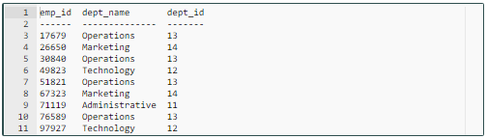  
To understand easily how LEFT JOIN works, we can use the following visual explanation. The shaded area represents all rows in the "employees" table and all matching rows in the "departments" table.

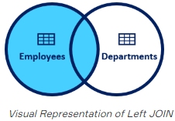

**Syntax**

query :

SELECT

employees.emp_id,

employees.first_name,

employees.last_name,

departments.dept_name,

departments.dept_id

FROM employees

LEFT JOIN departments

ON employees.emp_id = departments.emp_id;

output:

emp_id first_name last_name dept_name dept_id

---------- ---------- ---------- ---------- ----------

17679 Robert Gilmore Operations 13

26650 Elvis Ritter Marketing 14

30840 David Barrow Operations 13

49714 Hugo Forester null null

51821 Linda Foster Operations 13

67323 Lisa Wiener Marketing 14

70950 Rodney Weaver null null

71329 Gayle Meyer null null

76589 Jason Christian Operations 13

97927 Billie Lanning Technology 12

As a result of the LEFT JOIN operation, all ten rows are returned from the "employees" table and all matching rows in the "departments" table are returned. The rows that do not match with the right table are returned as null.